**Installation Notes for** **DTALite and NeXTA Version 1.1**

This documentation is designed to show users how to quickly install and use DTALite and NeXTA. the DTALite and NeXTA package can only run on Windows 7, Windows 10, Windows XP and Windows Vista.

Before starting the installation, please make sure you have unzipped the downloaded zip file “DTALite-NEXTA-Software-Package.zip”. There are two programs in this integrated GUI and simulation package, i.e., NEXTA and DTALite.

*Interfaces of DTALite and NeXTA*

|  |  |
| --- | --- |
| * NEXTA: front-end GUI (C++) |  |
| * DTALite: Open-source computational engine (C++)   + Light-weight and agent-based Dynamic Traffic Assignment   + Built-in OD demand matrix estimation (ODME) program |  |

**Step 1: Install required software packages.**

Required software packages are located in folder "Installation_required_software_packages".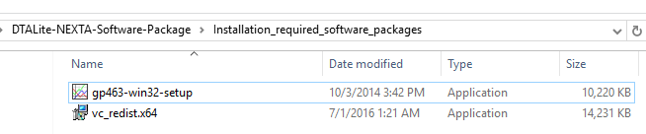

**Step 1.1: Install Microsoft Visual C++ 2015 Redistributable Package (x64).**

To use the parallel computing in DTALite, make sure that you have installed the Microsoft Visual C++ 2015 Redistributable Package (x64) "vc_redist.x64". The package can also be downloaded from <https://www.microsoft.com/en-us/download/details.aspx?id=48145>.

**Step 1.2: Install Gnuplot Software (x64).**

Make sure that you have installed Gnuplot Software (“gp463-win32-setup”) for the visualization purpose in NeXTA (<http://www.gnuplot.info/>).

**Step 2: Run DTALite.exe to test.**

Go to folder "Dataset_1_West_Jordan\West_Jordan_base_case" and run the executable "DTALite.exe". You are expected to see a black command window running for about 30 seconds to 1 min. Please ensure you are not working inside a zipped folder. If a the "dll missing" error message pops up when you run the application, then please ensure you have installed the correct Microsoft Visual C++ 2015 Redistributable Package in Step 1.1.

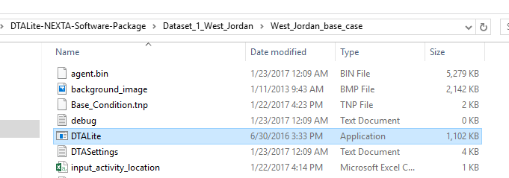

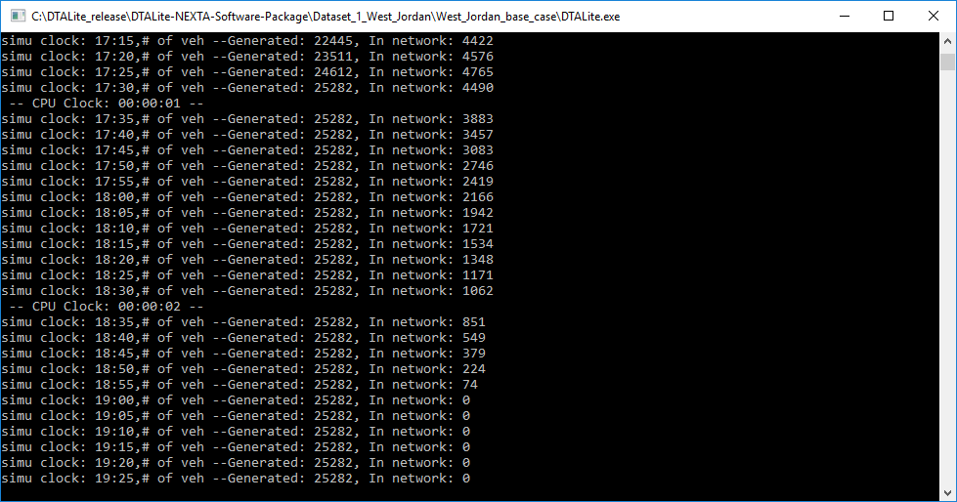

If you do not see the black command window, you can contact developers Dr. Xuesong Zhou at xzhou74@asu.edu and Jiangtao (Tony) Liu at jiangtao.liu@asu.edu for more information.

**Step 3: Check simulation summary.**

In the same folder, by opening file “output_summary.csv”, you are able to see the Software Version Number and Simulation Date (which should be close to your current time). Other simulation statistics (e.g., # of Nodes, # of Link Types, # of Links) can also be found in this file.

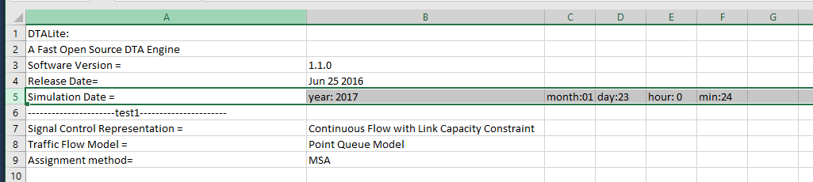

**Step 4: Use NeXTA to visualize West Jordan dataset.**

Go back to folder “DTALite-NEXTA-Software-Package” and double click on NeXTA.exe to run NeXTA.

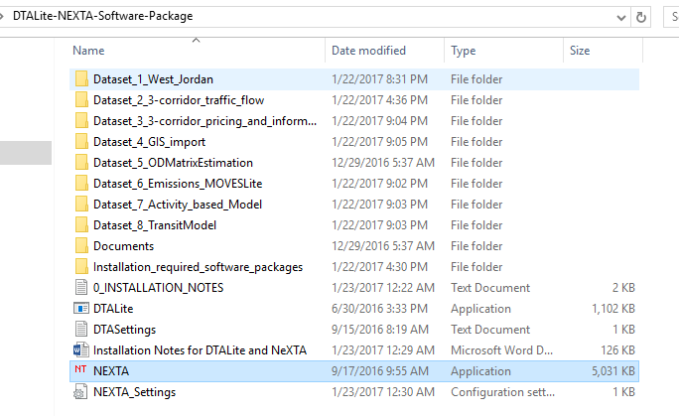

Click on the file open icon  in the toolbar. In the dialogue window, select file Base_condition.tnp in folder “DTALite-NEXTA-Software-Package\Dataset_1_West_Jordan\West_Jordan_base_case” and click on the File Open Button.

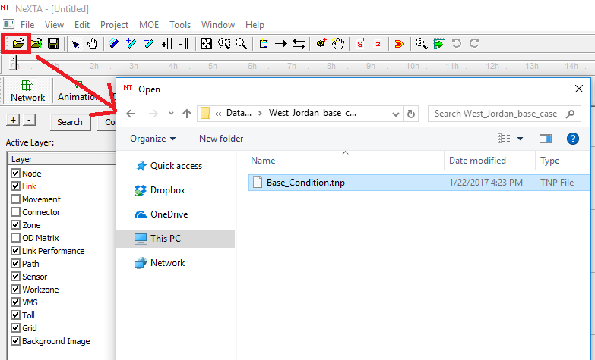

You should be able to see the following window.

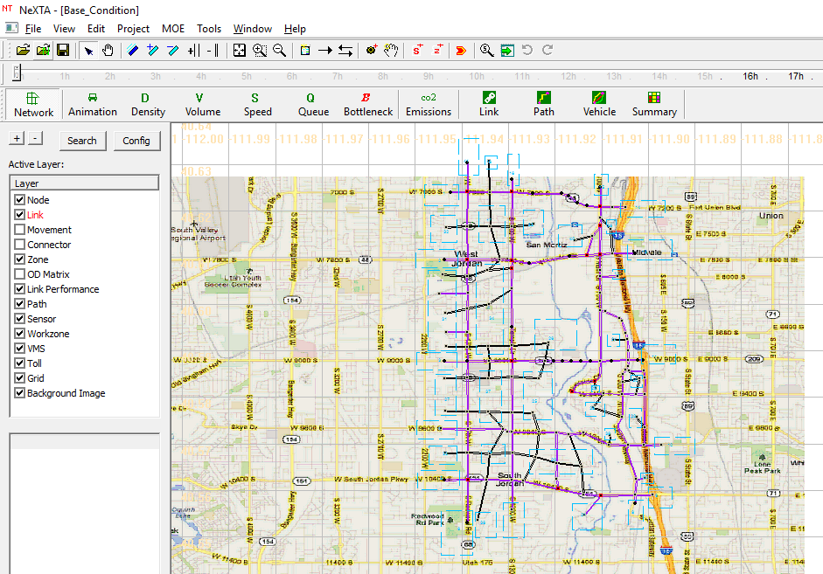

Please click on the run simulation button  in the toolbar, and run simulation to trigger the black command window.

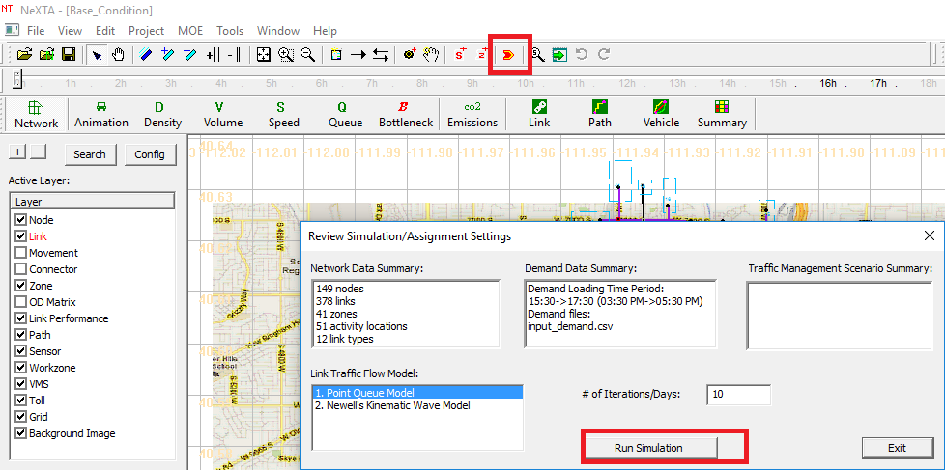\\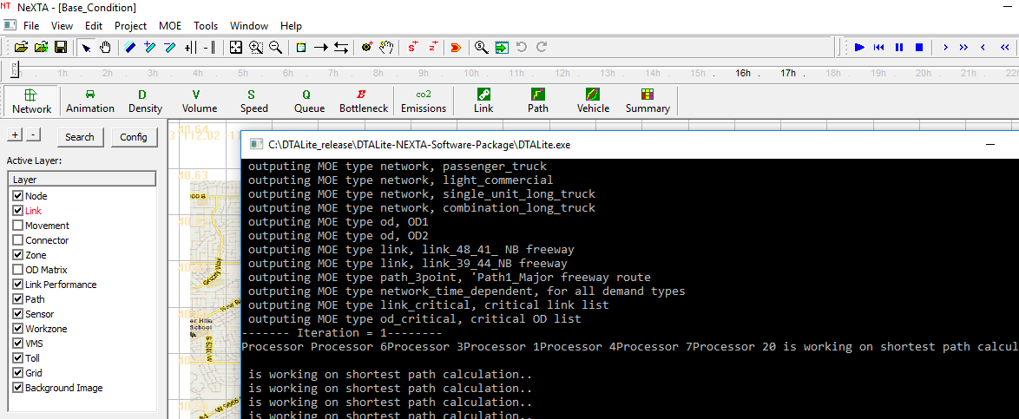

**Step 5: Find useful documents.**

Useful documents such as white papers, user guides, and training presentation files can be found under directory “DTALite-NEXTA-Software-Package\Documents”.

